What I did:

* Learned how to properly characterize the TVC mount movement due to rotation of the servo
* Created multiple equations to do this:
  + First, I assumed the linkage was parallel the entire time, which allowed me to make a linear approximation out of it:

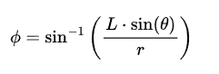

* + Second, I used vector math to create a system of nonlinear equations to accurately model the linkage mechanism with deflection in the linkage (i.e. not parallel the entire time)
  + I created two systems of equations: 1 for X-axis TVC movement, 1 for Y-axis TVC movement
  + I used MATLAB Optimization Toolbox to solve these

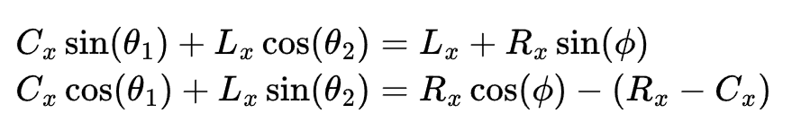

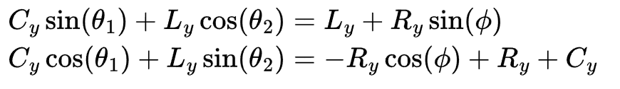

* Both the linear and nonlinear equations have very similar results in determining the Thrust Vector Angle
* The deflection angle of the linkage never exceeded more than 0.2-0.3 degrees, so modeling it as linear was a reasonable assumption

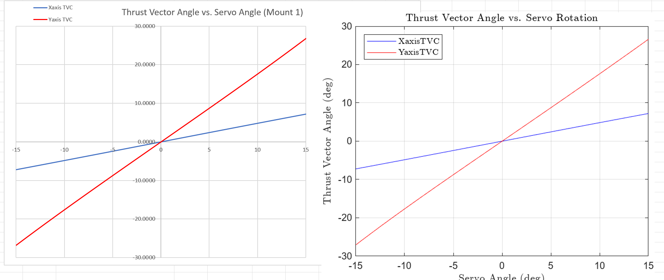

* From the linear equation we can see why the Xaxis TVC is much more stable than the Yaxis TVC
* In order to change the Thrust Vector Angle as little as possible with rotation of the servo we need to minimize the length of the control arm and increase the radius of rotation
  + For the x-axis the radius of rotation is about double the control arm length, which means the change in angle of the TVC is about 4x as great.
  + For example, if we move the X-axis servo 12 degrees, the x-axis TVC moves only 5.8 degrees
  + However, if we move the Y-axis servo 12 degrees, the y-axis TVC moves 21.2 degrees
* From this, I can see that ideally, we should increase the radius of rotation on the y-axis and decrease the control arm length to gain more control over the y-axis movement
  + A gear ratio might not actually be necessary, if we can gain more control through doing this
* I have pretty good control over the x-axis servo, so I will aim for similar control arm length and radius of rotation
  + I could also increase the radius of rotation and decrease the control arm length for both to get even more control
* Also, now that I know how to characterize the TVC rotation due to servo rotation, I’ll know how to control the rotation of the TVC with code -> I can just use the linear approximation since it’s quick and accurate